Off – Case

Kicking out of recommend CP

Conceed uniquness to DOL Trade off DA

Rate Hike DA

They have functionally conceded the rate hikes DA, only read 2 cards that did not address the link. There immediacy has an automatic and certain trigger of our link and that causes the impact. If they win certainty, it is an auto link.

Their cards say that unions hate rate hikes so we solve for the DA with the Plan: that’s terminal defense.

AT: Garwood ‘1-15

If they raise rates, it’ll be cautious and communicated in advance. UNTRUE because they implimented fiat which is immediate which means there is no time to adjust

AT - Galbraith ‘1-15

Hikes have zero statistical effect on the economy. Completely outdated and empirically untrue, pref our evidence as people do care about rate hike and cuts which they themselves have conceeded

2NC---Uniqueness---Cuts Now

Rate cuts are coming now.
ET '25. Economic Times. 08-13-2025. US Fed interest rate cut is now 100% possible, says report. When is Federal Reserve meeting date?. https://economictimes.indiatimes.com/news/international/us/us-fed-rate-cut-is-now-100-possible-says-report-when-is-federal-reserve-meeting-date/articleshow/123283507.cms?from=mdr. Economic Times. Accessed 8-14-2025.
The likelihood of a Federal Reserve rate cut in September is now seen near 100 per cent after new data showed U.S. inflation increasing at a moderate pace in July and Treasury Secretary Scott Bessent said he thought an aggressive half-point cut was possible given recent weak employment numbers. Traders in contracts tied to the benchmark federal funds rate on Wednesday put the odds of a quarter-percentage point cut at the Fed's September 16-17 meeting at 99.9 per cent, according to estimates calculated by the CME Group's FedWatch tool that followed the release of July Consumer Price Index data on Tuesday and later comments by Bessent noting that the Fed used fears of a weakening job market as justification for a larger cut last September.
Trump has slammed that cut as politically motivated given the proximity to the November presidential election. Bessent rooted his argument in recent Bureau of Labor Statistics revisions showing job growth had slowed to a crawl in May, June and July, though initial estimates for May and June showed stronger employment growth that Fed officials used to argue that the labor market remained in good shape.

2NC---Uniqueness---No Recession

A recession is not inevitable.
Max Zhan '25. Writer for ABC News. 8-6-2025. Is the US headed toward a recession? Experts weigh in. https://abcnews.go.com/Business/us-headed-recession-experts-weigh/story?id=124407347. ABC News. Accessed 8-14-2025.
The jobs report sent stocks tumbling but markets have since recovered.
"It seems to me people are anchoring on the jobs report and using it to telegraph a recession. I'm not sure it does that," Mark Blyth, a professor of political economy at Brown University, told ABC News.
"Nobody knows and everybody is doing wish fulfillment," Blyth added. "If you don't like the administration's policies, you're willing it to be a recession and if you like them, you're saying, 'no.'"
To be sure, recession forecasts are hardly bulletproof. A surge of inflation in 2021 -- and an interest-rate hike soon afterward -- unleashed a flood of recession warnings, but no downturn came to pass. More recently, Wall Street banks predicted a possible recession after Trump's "Liberation Day" tariff announcement, before pulling back their assessments after Trump dialed back the levies.
"Recessions tend to be unforecastable," Claudia Sahm, chief economist at New Century Advisors and a former Fed official, told ABC News. "Often there's an event that causes people to lose confidence, change behavior and start a downward spiral. Those events are very hard to predict."

2NC---Link---Unions

Strengthening unions causes rate hikes – the fed feels inflationary pressure and responds by raising rates – empirics prove. That’s Burns.

1. WAGE PRICE SPIRAL. Inflation is seen as different before because of weak labor laws.
Pierre Yared '22. MUTB Professor of International Business. 12-7-2022. Interest Rates and Inflation: What's Next for the Federal Reserve?. https://business.columbia.edu/insights/finance-economics/interest-rates-and-inflation-whats-next-federal-reserve. Columbia Business School. Accessed 8-13-2025.
Yared: There are three big differences that suggest that most likely inflation will not be as bad as the 1970s. First, there are structural differences to the economy now relative to the 1970s that limit the extent to which inflation can keep going up. In particular, unions are not as strong as they were before. With less collective bargaining, the wage-inflation spiral, where the demand for higher wages increases labor costs and fuels more inflation and so on, is less of a factor.

Wage-Price Spiral is true – just look at how inflation rate is correlated with wages.
Lance Roberts ’23. Chief Investment Strategist for RIA Advisors and Lead Editor of the Real Investment Report. 05 May 2023. “Minimum Wage & The Fed’s Biggest Fear.” https://realinvestmentadvice.com/minimum-wage-the-feds-biggest-fear/. Accessed 13 August 2025.
The Wage Spiral
How can hiking the minimum wage foster a wage spiral?
Let’s look at an example parcel carrier job that currently pays $15/hour and has the following work requirements.
Lifting boxes up to 150 lbs.
Loading and unloading trucks in a warehouse that can be freezing or sweltering,
Driving a large truck anywhere from 10-150 miles a day,
Customer interaction,
Route planning.
What would be the consequences of raising the minimum wage to $15/hour for this worker?
There are two possible outcomes.
Instead of lifting parcels of up to 150 lbs per day, they quit for a much easier job for the same pay; or
Demands a pay raise (which, if they don’t get the raise, they quit to take a much easier job.)
The parcel carrier service acquiesces and raises them to $20/hour. However, now the managers making $20/hour want a raise, and so forth. It is the same effect as throwing a rock into a pond. Yes, the rock (in this case, the number of minimum-wage workers) may be small, but the “ripple effect” to the pond’s edges becomes substantial.
As wages increase at the bottom, there is a trickle-up effect on all workers. Importantly, those accelerating wage costs ultimately must pass on to consumers, otherwise known as inflation. That cycle of rising wages and prices is the “wage-price spiral.” The Fed already got a taste of the problem with the influx of stimulus into the economy, which led to surging demand when employees were scarce.
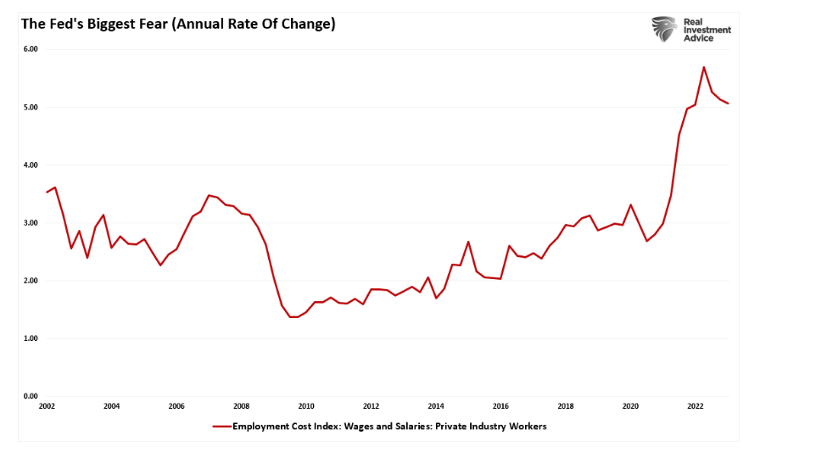
Such is also why the Federal Reserve remains committed to keeping interest rates elevated to slow economic demand (which, in turn, will lower wages as unemployment increases) to reduce inflationary pressures.
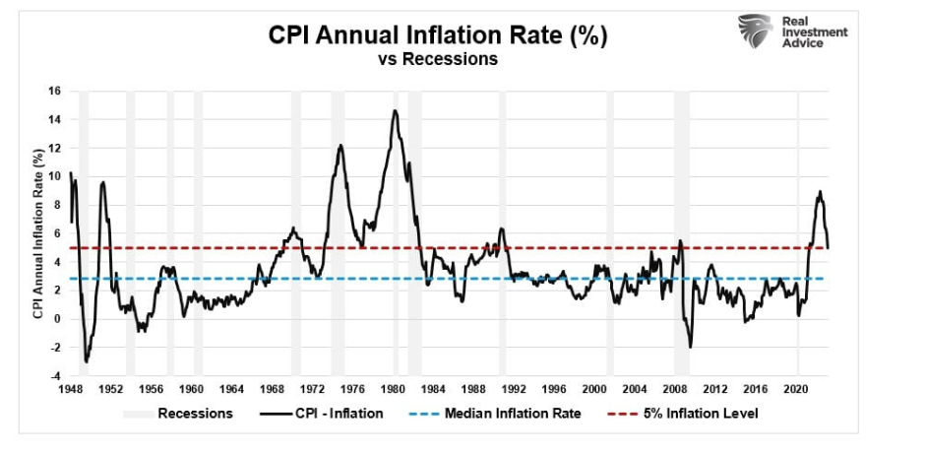

2. INFLEXIBLE ECONOMIES.
Michael Watson 24, Research Director for Capital Research Center, managing editor for InfluenceWatch, graduate of the College of William and Mary, former employee of a Washington, D.C. public relations firm, "The Cases Against Sectoral Bargaining: The Economic Case," Capital Research Center, 8/8/2024, https://capitalresearch.org/article/the-cases-against-sectoral-bargaining-part-5/
The Economic Case
For all the ideological and social-policy arguments inherent to labor-relations policy, labor-relations policy is fundamentally economic. Everyone who works for pay and everyone who employs workers is affected by the labor regime. It affects all economic activities. And on the question of the economic effects of European-style sectoral bargaining versus American-style enterprise bargaining, the world has been running a sort of general economic experiment since the end of social democracy’s “thirty glorious years” in the 1970s.
The results are in, and the Americans beat the French.
There is no evidence that France has had greater economic success than the United States. As of 2016, its gross domestic product at purchasing power parity (that is, adjusted for the cost of living) was lower than all U.S. states except Idaho and Mississippi. Even leftist measures that consider life expectancy, obesity rates, or wealth inequality show the United States as better off. More recent research shows the European economy falling even further behind the U.S. economy, even as Americans have complained about stagnation in their own country. The same social and economic problems—uncontrolled immigration, declines in manufacturing employment, and political instability and loss of social cohesion—have not been helped obviously by a stronger organized labor movement with more coercive power in France. The 2024 national legislative elections saw the liberal party of President Emmanuel Macron lose votes to populists of right and left, with the neo-communist Unsubmissive France (La France Insoumise) and the party of the controversial Marine Le Pen, the National Rally (Rassemblement National) surging in vote share and legislative seats. The country may be ungovernable until another legislative election is called or President Macron resigns.
Then there is the question of cost of living and consumer prices. In the U.S., higher-cost-of-living states often have strong labor union movements. Even where labor relations policies are not the cause of these higher costs, labor unions’ institutional leftism encourages regulatory and legislative environments that dissuade business formation, restrict construction, raise the price of energy with environmentalist mandates, and hike taxes.
Supporters of sectoral bargaining focus on the potential of the policy to raise nominal wages before considering inflation or changes in cost of living. In a late 2020 policy paper issued while he chaired the House Education and Labor Committee (the committee name changes from Education and Labor to Education and the Workforce whenever the House majority changes), left-wing Rep. Bobby Scott (D-VA) argued, “Centralized bargaining benefits employers and employees by removing wages from competition, enabling employers to compete over the quality of their products or services.” But this ignores price competition that helps consumers and controls the “wage-price spiral” that exacerbated the inflation of the 1970s.
In discussing the causes of Big Labor’s Long Decline, I wrote:
Big Labor had risen in an environment of privation and war, but the country now identified with—and demanded—plenty and peace. The late 1970s and early 1980s saw the American consumer flex its power, demanding that something—anything—be done to curtail rampant inflation. After the predictable failure of wage and price controls enacted by the Nixon administration and the pathetic “Whip Inflation Now!” campaign of the Gerald Ford administration, a bipartisan consensus emerged, first under Jimmy Carter, in favor of deregulating the national economy.
If the public-opinion response to the economy under the Biden administration is any indication, Americans still absolutely loathe inflation. Adjusting economic policy to raise the cost of living, a certainty under sectoral bargaining, would likely trigger the American consumer’s visceral response to higher prices.
Some, most prominently Oren Cass of American Compass, have argued that sectoral bargaining would become an alternative to government labor-standards regulation, with sectoral bargaining unions and employer associations able to come to mutual agreements to waive certain government rules.
Cass sells it as a win-win, but it runs into the problem of incentives. Unions have no reason to negotiate below the level set by a government minimum labor standard. Well, no honest reason: They have at least two dishonest reasons. One is straightforwardly corrupt labor-management collusion, like what happened in the previous regime at the United Auto Workers. Corrupt managers pay corruptible union officials to keep them “fat, dumb, and happy” and to do management favors.
The second dishonest reason is both more subtle than simple corruption and also completely legal. Currently, union-backed politicians often include waiver clauses in local wage-minimum laws that create a curious carveout: They don’t apply to a collectively bargained contract. Unions—not necessarily union members—profit from this arrangement in easier organizing and more dues collections, since they can hold the possibility of avoiding these rules as a carrot to secure a card-check union recognition.
Without details on what an American sectoral bargaining system would involve, the potential to abuse of employee autonomy using Cass-promoted waiver clauses is limitless. Unions run by corrupt officials could take kickbacks for going below national standards. Unions run by leftist activists could use their ability to collude with employer associations to enshrine left-wing social policy in workplaces nationwide. Either class could use the ability to collaboratively waive regulations to secure what is euphemistically called “union security”; that is, forced dues, unless there were a national right-to-work-style protection that Cass’s allies in Congress have not endorsed.
Conclusion
Sectoral bargaining is not the answer to conservative cultural concerns or broader economic problems. Adopting it would repudiate the practical gains of the Taft-Hartley consensus to empower a Democratic Party constituency group steeped in socialist ideology with no obvious case that it would benefit the economy.

3. REAL ECONOMIC UNCERTAINTY.
Juan M. Londono et al. '25. International Financial Stability Section International Finance. Sai Ma Senior Economist
International Financial Stability Section
International Finance. and Beth Anne Wilson Program Direction Section
International Finance.4-24-2025. Costs of Rising Uncertainty. https://www.federalreserve.gov/econres/notes/feds-notes/costs-of-rising-uncertainty-20250424.html. No Publication. Accessed 8-13-2025.
The Real Economic Uncertainty (REU) measure in Jurado, Ludvigson, and Ng (2015) captures the predictability of the macroeconomy; the less predictable, the higher is REU. As the economy becomes less predictable, households and businesses change their behavior, including increasing precautionary savings and postponing expenditures and investment, especially if they are irreversible.9 Firms may also delay or even freeze hiring (Leduc and Liu, 2016). Consequently, heightened REU negatively impacts economic activity by dampening investment, consumption, and labor market participation. The economic effects of REU are amplified in the presence of financial frictions, particularly when credit access is constrained (Arellano, Bai, and Kehoe, 2019). During periods of heightened uncertainty, financial institutions become more risk-averse, tightening lending conditions and increasing borrowing costs, which makes it more difficult for firms to secure credit for investment.

One specific type of economic uncertainty is that related to inflation, which was certainly elevated as economies around the world emerged from COVID to face labor shortages, supply chain bottlenecks, and surging commodity prices. Inflation uncertainty arises when businesses, households, and policymakers face difficulty in predicting future price levels. Londono, Ma, and Wilson (2023) find that inflation uncertainty has significant macroeconomic repercussions, particularly through its impact on investment. This impact on investment is explained by two channels that are consistent with the option-pricing theory: a discount rate channel, where rising inflation uncertainty increases both the monetary policy rate and its uncertainty, and a cash flow uncertainty channel linked to the uncertainty about input costs. For households, uncertainty about future inflation expectations influences consumption and savings decisions, often leading to higher precautionary savings and reduced spending (Bachmann, Berg, and Sims, 2015).

Strengthening labor law shreds R&D. That’s 1NC Francis.

1. PRODUCTIVITY---falls after unionization.
Daniel Bradley et al. '17. Department of Finance, University of South Florida. Incheol Kim works for the Department of Finance, Fordham University. Xuan Tian works for the Department of Finance, Indiana University, Bloomington, July 2017. “Do Unions Affect Innovation?.” https://scholarworks.utrgv.edu/cgi/viewcontent.cgi?article=1003&context=fin_fac. Management Science, 63(7), pp.2251-2271. Accessed 6-3-2025.
In this paper, we examine the effect of unionization on the innovation activities of firms. We find patent counts and citations decline significantly after firms elect to unionize. Economically, passing a union election leads to an 8.7% decline in patent counts and a 12.5% decline in the number of citations per patent three years after the election. We provide a battery of diagnostic and robustness tests and find our conclusions are unchanged. Next, we show that the results are statistically insignificant in states with right-to-work legislation where unions have less bargaining power to expropriate rents. A reduction in R&D expenditures, reduced productivity of existing and newly hired inventors, and the departure of innovative individuals appear plausible underlying mechanisms through which unionization impedes innovation. Finally, in response to unionization, we find that firms move their innovation activities away from states where union elections win.

Bradley’s regression discontinuity is the best metric to establish causation between innovation and bargaining.
Harald Dale-Olsen ‘25. Research Professor at the Institute for Social Research (ISF) in Oslo. 2025. Technological Development, Market Power and (The Role Of) Unions. https://pub.norden.org/nord2025-001/technological-development-market-power-and-the-role-of-unions.html. Nordic Economic Policy Review 2025. Accessed 6-6-2025.
8 Technology implementation, innovation, and types of innovation
Innovation causes increased productivity and economic growth and can address societal problems (OECD, 2015). As Aghion et al. (2014) point out, innovation drives productivity growth by either reducing costs, improving product quality, or both. One way to reduce costs is to adopt labour-saving technologies, which naturally makes innovation a key concern for trade unions.
Theoretically, the implications for how unions affect firms and workers with respect to innovation are threefold. One strand of the literature focuses on the previously discussed hold-up effect, where the sunk-cost nature of R&D provides unions with rent-extracting powers, which then causes under-investment. The other strand of literature acknowledges the hold-up effect but shifts the focus to how market and bargaining structures can act as counterforces (Ulph and Ulph, 2001). Within this perspective, the incentives for innovation may be stronger under centralised bargaining (Haucap and Wey, 2004) or local bargaining (Braun, 2011). The third strand focuses on how the impact of unions differ when innovations can be counteracted or shaped (Lommerud and Straume, 2012; Berton et al., 2021; Bryson and Dale-Olsen, 2022). In these cases, unions tend to promote product innovation while actively seeking to avoid labour-saving innovation.
Empirically, the evidence of how unions affect innovation is equally mixed. To an extent, this probably reflects the lack of causal studies. Most empirical studies of unions and innovation are based on correlations. During the last decades, the two survey articles by Menezes-Filho and Van Reenen (2003) and Doucouliagos and Laroche (2013) found typically negative correlations in Anglo-Saxon countries and those with weaker labour regulation but non-negative relationships between unionisation and innovation in European countries. Surprisingly, however, Addison et al. (2017) observed that sectoral bargaining in Germany was associated with greater innovation, while Berton et al. (2021) observed that product innovation increased with union strength in Italy for 2010–18, and only a very strong or a very weak union had a negative effect on process innovation.
In a comparison of Norway and the UK in 2010/2011, Bryson and Dale-Olsen (2022) observe support for the notion that local bargaining is more conducive to innovation, whether product and process innovations occur jointly or product innovation happens on its own. This confirms that unions tend to favour product innovation over labour-saving innovation, but when both types occur, the benefits from greater product demand can offset the utility loss from labour-saving technologies. Furthermore, acknowledging the possibility of selection effects, it is notable that during the COVID-19 pandemic, Norwegian firms with a collective agreement were much more likely to introduce new technology (not just online meeting platforms like Zoom) than those without such agreements (Barth et al., 2024). Non-unionised firms were similarly much more likely to postpone planned investments. Why? While this study does not explicitly explain why, they do attempt to test different explanations. The authors find that it was not driven by unionised firms being more productive than non-unionised ones, nor is it associated with size, industry, financial problems or the scale of disruption. What explanations does that leave? We know that unions ameliorate stress among workers when organisational changes occur, implying reduced implementation costs (Bryson et al., 2013). One interpretation could, therefore, be that unionisation in Norway implies a certain flexibility and adaptability not found among non-union firms, thereby potentially reducing and ameliorating negative implementation costs, a trait that proves valuable during unexpected shocks.
Among U.S. studies, the work by Bradley et al. (2021) stands out for using a regression discontinuity (RD) approach to examine the causal relationship between unionisation and innovation. As described earlier, bargaining following unionisation in the U.S. comes after a local workplace ballot that requires a majority vote. Thus, Bradley and co-authors compare firms just above and just below this threshold (the Wagner threshold) with the weaknesses this might entail (close ballots reflect weaker unions). Applying this RD approach, Bradley et al. find that unionisation causes reduced patent quality and quantity. Why this is so is not clear. From Section 6, we remember that Frandsen (2021) observed that when collective agreements were established following a ballot, the older and higher-paid workers (potentially the most senior and productive) left the firm. Thus, one explanation could be that the most innovative workers exit the organisation. Additionally, Bradley et al. show that firms are shifting their innovation activities from states where unions have been successful in organising to states where unions are weaker.

Globalization
They have no proof that secondary strikes would lead to globalizayion, there are other countries with legal secondary strikes and no globalization of the degree they are claiming have occurred. Also, places burden to protect US workers abroad rather than taking the acountability to for ourselfves. Their conciousness arg falls through bc again, conciusness has not occurred when secondarty strikes are legal and we have no reason to belive it would happen now

